IMPORTANT – before you start doing your solution, MUST do the following steps:

- Create your MS SQL database named PRJ311 by running code in script
PRJ311DB.sql.
- Create a folder named jdbc (1) under your project, copy given file sqljdbc42.jar to (1)
- Copy given file DBContext.java (2) to source package (src\java) folder under your netbeans project. You might need to use and name a java package for (2), free to set the name of package.
- You MUST use DBContext.java for your all database connection.

Question 2: (4.0 Point)
Design the form, which at running might look something like figure below: (0.5 Point)
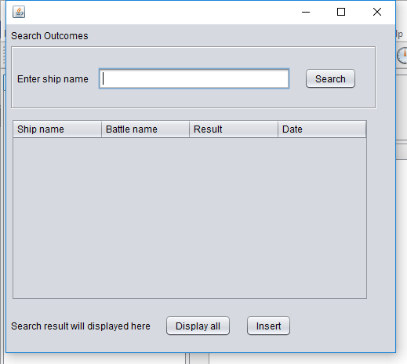
When a user click on the button “Display all” the form looks like below:
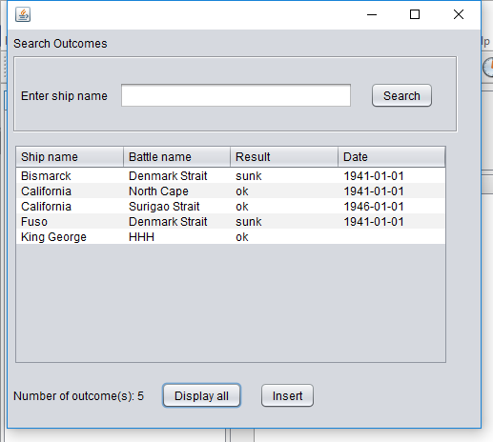
When users enter value for ship name and click Search button, output information of all outcomes in Outcomes table to below table which have ship name contains entered value (2.0 Point) also output the number of rows/records found (0.5 Point).

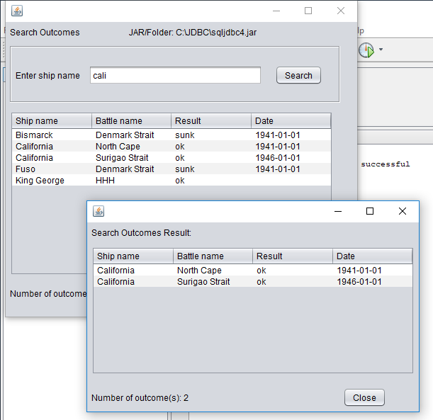
Output a message “Not found any Outcome” if the system could not find any matched Outcome (1.0 Point).
